3.5 Giant and molecular structure
Name: ____________________ Class: ____________________ Due date:
1.Which statement describes the attractive forces between molecules (intermolecular forces)? （ ）
A They are strong covalent bonds which hold molecules together.
B They are strong ionic bonds which hold molecules together.
C They are weak forces formed between covalently- bonded molecules.
D They are weak forces which hold ions together in a lattice.

2. The diagrams show the structures of three macromolecules P, Q and R. 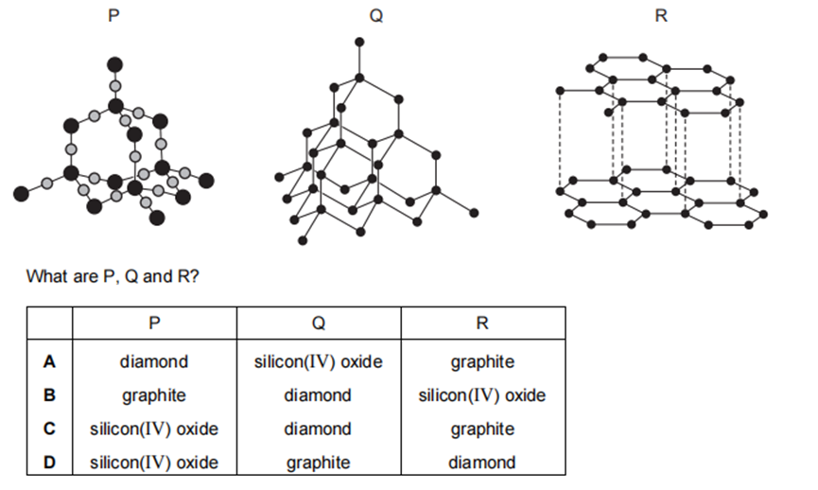
What are P,Q and R? （ ）

3.Which substances have similar structures? （ ）
A diamond and graphite
B diamond and silicon(IV) oxide
C graphite and poly(ethene)
D graphite and silicon(IV) oxide

4.Ethanol is a liquid at room temperature and boils at ${78}^{∘}C$
Sodium chloride is a solid at room temperature.
Which statement about bondings in ethanol and sodium chloride is not correct?（ ）
A Each ethanol molecule is held together by weak covalent bonds.
B The ethanol molecules are held together by weak attractive forces.
C The sodium ions and chloride ions are held together by strong attractive forces.
D The sodium ions and chloride ions are held together in a giant lattice.

6. Two statements about silicon(IV) oxide are given.
1 It is a hard substance.
2 It has a macromolecular structure with strong covalent bonds.
Which is correct? （ ）
A Both statements are correct and statement 2 explains statement 1.
B Both statements are correct but statement 2 does not explain statement 1.
C Statement 1 is correct but statement 2 is not correct.
D Statement 2 is correct but statement 1 is not correct.
7.How are the structures of diamond and silicon(IV) oxide similar? （ ）
A Molecules of both diamond and silicon(IV) oxide are held together by weak attractive forces.
B They both contain atoms arranged in planes held together by weak bonds.
C They both contain ions that are free to move.
D The carbon in diamond and the silicon in silicon(IV) oxide each have four covalent bonds.

8.How many silicon atoms are bonded to each oxygen atom in a crystal of silicon(IV) oxide? （ ）
A 1 B 2 C 3 D 4

9. Silicon(IV) oxide is a covalently bonded compound.
Which statements are correct? （ ）
1 Silicon atoms form four single bonds in silicon(IV) oxide.
2 Oxygen atoms form two double bonds in silicon(IV) oxide.
3 Silicon(IV) oxide has a high melting point.
4 Silicon(IV) oxide contains one silicon atom and four oxygen atoms.
A 1 and 2 only B 1 and 3 only C 2 and 3 only D 3 and 4 only

11. Carbon and silicon are elements in Group IV.
They both form oxides of the type XO₂.
(a) Silicon(IV) oxide, SiO₂, has a macromolecular structure.
Describe the structure of silicon(IV) oxide.

(b)Explain why the physical properties of carbon dioxide are different from those of diamond and silicon(IV)oxide.

12. Silicon(IV) oxide and sodium chloride have different types of bonding and structure.
(a) Name the type of bonding present in
silicon(IV)oxide,
sodium chloride.
(b) Name the type of structure present in silicon(IV) oxide.
(c) (i) Silicon(IV) oxide has a high melting point. Explain why.
(ii) Silicon(IV) oxide is a poor conductor of electricity. Explain why.
(d) Solid sodium chloride does not conduct electricity. However, it conducts electricity when molten.Explain why solid sodium chloride does not conduct electricity, whereas molten sodium chloride does conduct electricity.

14. Silicon lies directly below carbon in Group IV of the Periodic Table.
Here is some data for silicon, carbon (in the form of diamond), and their oxides.
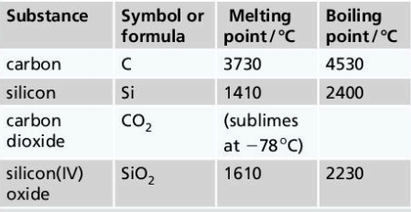
a Which type of structure does carbon (diamond) have: giant covalent, or molecular?

b Which type of structure does carbon dioxide have: giant covalent, or molecular?
c Which type of structure would you expect to find in silicon? Give reasons.

d Carbon dioxide has a molecular structure.
Are the intermolecular forces in it strong, or weak?

